Lab Manual



Course: BI-402

Bioinformatics Software Development

Term: Fall 2020, Class: BSBI-2017

Submitted By:

TALHA NAEEM 2017-BI-005

(Name) (Roll. No.)

Submitted To:

**Ms. Mehwish Mehmood**

**Department Of Bioinformatics**

**Sir Syed University Of Engineering and Technology**

**University Road Karachi - 75300**

<http://www.ssuet.edu.pk>

**LAB 4**

**Web Development Framework Using**

**“Dreamweaver CS 5”**

**Q1:** Create a login form using Heading, label, text field, button, table and image tag.

**SOURCE CODE:**

<!doctype html>

<html>

<head>

<meta charset="utf-8">

<title>MY WEB PAGE</title>

</head>

<body>

<center><img src="../../Downloads/log.png" width = "200" height = "200" alt=""/></center>

<br>

<center><label>Username</label>

<input type = "text" placeholder="Enter UserName"></center>

<br>

<center><label>Password</label>

<input type = "text" placeholder="Enter Password"></center>

<br>

<center><input type="button" value="Login">

<input type = "button" value="Cancel"></center>

<br>

<center><input type="checkbox">

<label>Remember me</label></center>

<center><label>Forgot <a href=>password?</a></label></center>

</body>

</html>

**OUTPUT:**

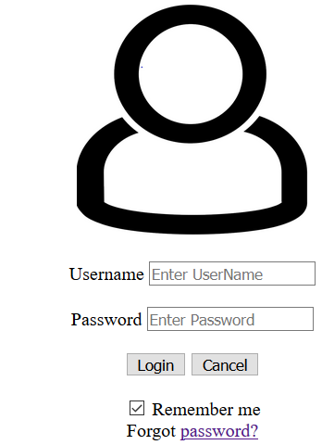

**Q2:** Create your timetable using Html commands.

**SOURCE CODE:**

<!doctype html>

<html>

<head>

<meta charset="utf-8">

<title>TIME TABLE</title>

</head>

<center><h1>Sir Syed University of Engineering and Technology,Karachi</h1></center>

<center><h2>Department of BioInformatics</h2></center>

<center><h1>TimeTABLE OF Class BI8</h1></center>

<br>

<center><table border="4" width="150" border="3" align="center" cellspacing="7" cellpadding="2"><tbody></center>

<tr>

<center><th scope="col">Friday:

<td> 8:30-10:00

<td>10:00-11:30

<td>11:3-1:00

<td>1:00-2:30

<td>2:30-4:00

<td>4:00-5:30

</tr>

<tr>

<center><th scope="col">Timings:

<td>8:30-10:00

<td>10:00-11:30

<td>11:3-1:00

<td>1:00-2:30

<td>2:30-4:00

<td>4:00-5:30

</tr>

<tr>

<center><th scope="col">Period Day:</th></center>

<td>1

<td>2

<td>3

<td>4

<td>5

<td>6

</tr>

<tr>

<center><th scope="col">Tue</th></center>

<td>DS-7 BSDTh Mehwish</td>

<td>DS-7 Med_Imag Haleem</td>

<td>DS-7 Ethics Sehar</td>

<td> </td>

<td>DS-7 STinB Uzma</td>

<td> </td>

</tr>

<tr>

<center><th scope="col">Wed</th></center>

<td>DT-4 BSDPr Mehwish</td>

<td>DT-4 BSDPr Mehwish</td>

<td> </td>

<td> </td>

<td>DS-8 Med_Imag Haleem</td>

<td>DT-8 BSDTh Mehwish</td>

</tr>

<tr>

<center><th scope="col">Thu</th></center>

<td>DS-6 Ethics Sehar</td>

<td>DS-6 STinB Uzma</td>

<td> </td>

<td> </td>

<td> </td>

<td> </td>

</tr>

<body>

</body>

</html>

**OUTPUT:**

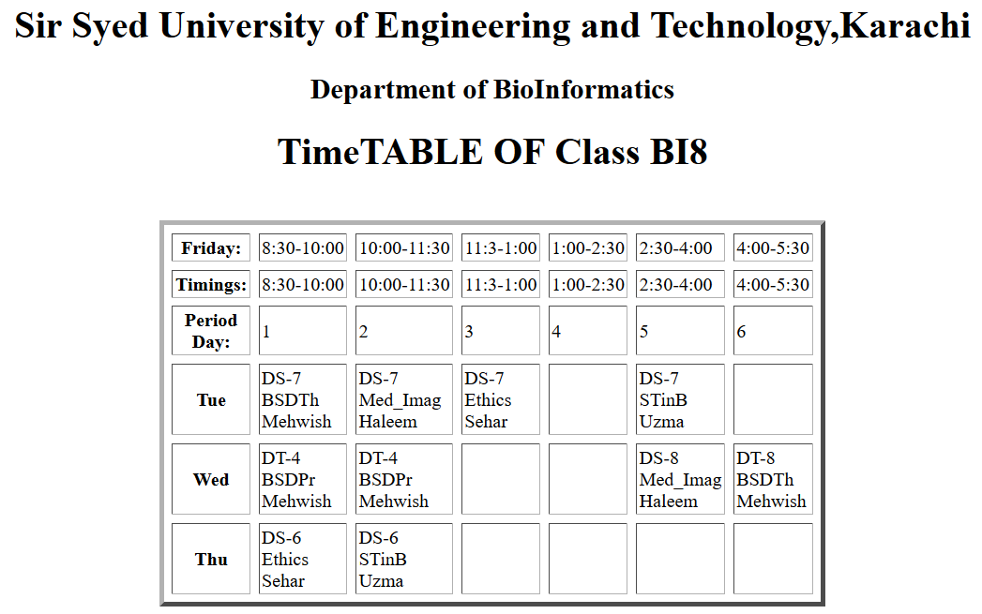

**Q3:** Create the following page using ordered and nesed ordered list.

**SOURCE CODE:**

<!doctype html>

<html>

<head>

<meta charset="utf-8">

<title>Untitled Document</title>

</head>

<center><h1>Web Site Online</h1></center>

<ol><li>Home Page<li>Link Page</li>

<ol type="I">

<li>Link to Search Engines</li>

<li>Link to Information Site</li>

<ol><ol type="A">

<li>New Site</li>

<ol type="i">

<li>TV based</li></ol>

<ol><ol type="a">

<li>CNN</li><li>Headline</li></ol></ol>

<li>Stock Site</li>

</ol></ol>

<li>Links to Fun Site</li>

</ol>

<li>Contact Page</li>

</ol>

</body>

</html>

**OUTPUT:**

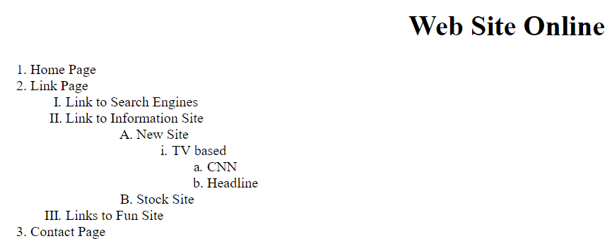

**Q4:** Design and create a web page as shown below. Use proper image and form tags and different input fields.

**SOURCE CODE:**

<!doctype html>

<html>

<head>

<title>LAb4task3</title>

<style>

body{background-image: url("file:///C:/Users/Lenovo/Downloads/sidepage.png");background-position: center; background-repeat: no-repeat;background-attachment: fixed;background-size: cover}

body{

background-color: hotpink; background-position: center;font-family: Cambria, "Hoefler Text", "Liberation Serif", Times, "Times New Roman", "serif"; alignment-baseline: center

}

</style>

<body>

<center><body><h1><b>Apply Online</h1><center>

<center><label>First Name</label>

<center><input type = "text" placeholder="Enter Name"></center>

<center><label>Last Name</label></center>

<center><input type = "text" placeholder="Last Name"></center>

<center><label>Send E-Mail to quickmoon@rocketmail.com</label>

<center><label>Name</label></center>

<center><input type = "text" placeholder="your name"></center>

<center><label>Email</label></center>

<center><input type = "text" placeholder="your email"></center>

<center><label>Comment</label></center>

<center><input type = "text" id="comment " name="comment" value="your comment" size="47"></center>

<center><input type="button" value="Send"></center>

<center><input type="button" value="Reset"></center>

<br>

<center><label>Select Gender</label><br>

<center><input type="radio" id="male" name="gender" value="male"><label for="male" >Male </label></center>

<center><input type="radio" id="female" name="gender" value="female"><label for="female">Female</label></center>

<br>

<center><label>Select your field of interest</label>

<center><select name="subjects" id="subjects">

<option value="Maths">Maths</option>

<option value="AI">AI</optio

><option value="Web">Web</option></select><center>

<br>

<center><label>Select your major</label>

<center><select name="subjects">

<option value="Maths">Maths</option>

<option value="AI">AI</option>

<option value="Web">Web</option></select><center>

<br>

<center><label>Type some text(if you like):</label></center>

<center><input type = "text" id="text " name="text" value="your text" size="47"></center>

<br>

<center><label>Please specify a file,or a set of files:</label></center>

<center><input type="button" value="Choose file"><label> No file chosen</label></center>

<br>

<center><input type="button" value="Send"></b></center>

</body>

</html>

**OUTPUT:**

